How to create predicted items without a POL (acquisitions order) | 

Yoel Kortick
Senior Librarian

This document will explain how to create predicted items without have a POL connected to the bibliographic record and items.

For more in depth information regarding creating predicted items see presentations here.

Note that when creating predicted items without a POL the items will not include calculated “expected arrival” dates. This is because the expected arrival dates come from vendor attached to POL.
When there is no POL the expected arrival date will be the issue date.

ONE

Create a holdings record from the bibliographic record
Here we create a holdings record for title “Cybermetrics: international journal of scientometrics, informetrics, and bibliometrics.”

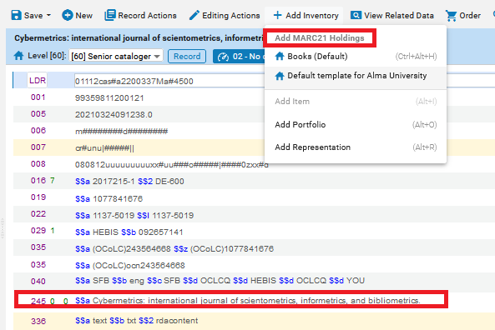

TWO

Add desired 853 field to the holdings record, either manually or via ‘expand from template’

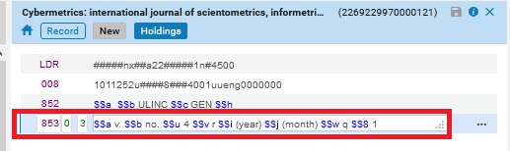

THREE

Access the “Next predicted item’s information” from the “Record Actions” menu.

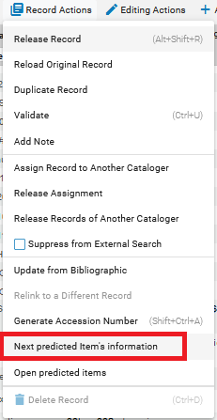

FOUR

Fill in as desired and close the window

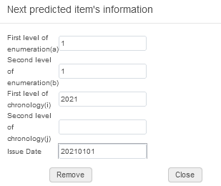

FIVE

Access the “Open predicted items” from the “Record Actions” menu.

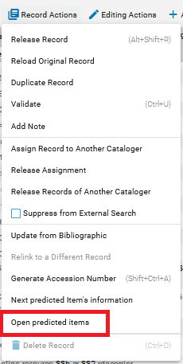

SIX

View the predicted items and save (or, discard the items, change the 853 field of the holdings record, and reopen the predicted items)

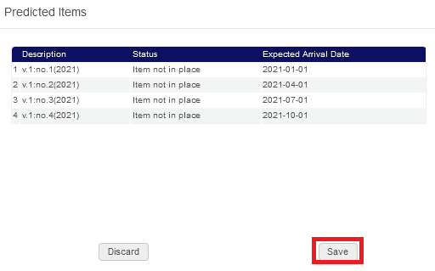

SEVEN

See that there are now predicted items

